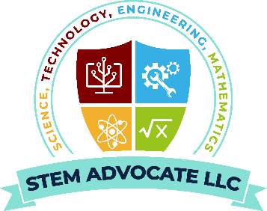
STEM ADVOCATE LLC SCHOLARSHIP:
BOOKS, OTHER EXPENSES, FEES

STEM Advocate LLC aims to increase the number of STEM professionals, one student at a time. We are vested in each student’s individual aspirations and believe all career objectives are achieve-able with discipline, relentless work ethic, professional mentorship, resources, and support.
We are excited to provide annual scholarships to high school seniors pursuing degrees, certifications, or trades in the areas of science, technology, engineering, or mathematics.

Up to 5 Book or Other Expense Scholarships will be awarded ($250 - $500 each).
To qualify, please submit the below criteria to stemadvocatellc@gmail.com by March 31st annually.

Scholarship Application Requirements:
1. Eligibility Criteria:
- Must be a high school senior
- Minimum 3.0 GPA required
- Must submit acceptance letter to university, college, trade school, that you will attend.
- Must submit ‘personal statement of commitment’ from candidate to university, college, trade school you will attend.
2. Application Criteria:
- Personal information:
  - Name, Mobile number, Email
  - Parent/guardian name, Mobile number, Email
  - High School Name, Address, Phone number
- Future Institution Information: Institution name, address, phone number

- Essay/Paragraph Submissions (Typed):
  - Personal essay (one-pager only, pdf format) to describe the student’s plans in STEM, include:
    - What area of STEM will you pursue and why?
    - What inspired you to pursue this STEM major?
    - STEM-related extracurricular activities or volunteer work (if any)
    - What impact will you make on society leveraging your STEM major?
    - How will you pay it forward to help others in the future?
- Parental/Legal Guardian Essay (one-paragraph, pdf format):
  - Share how proud you are to celebrate this milestone with your child?
  - Why do you believe your child will be successful in STEM?
  - How do you plan to support and enable your child’s success?

- Selection & Award Process:
  - Our committee will review applications based on the above criteria: quality of essay, parental essay, academic performance, career goals, verification of high school and future institutions attendance.
  - Winners will be notified by April 30th with the amount awarded.

