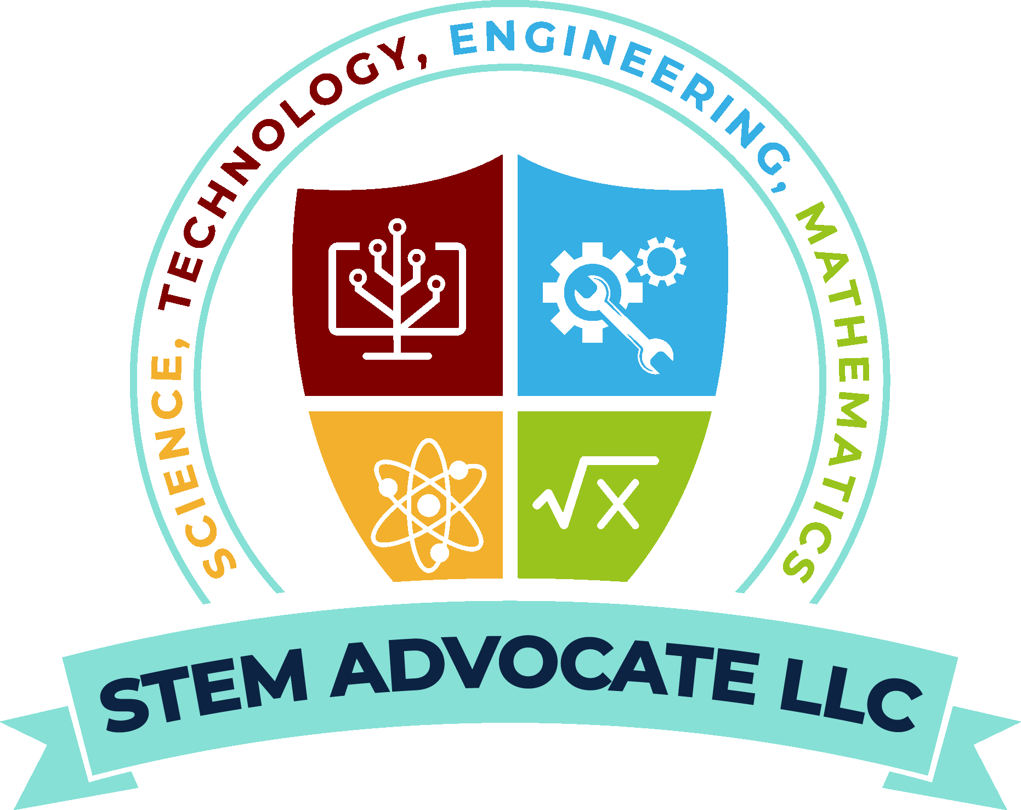
STEM ADVOCATE LLC
Executive Capability Statement
For Superintendents, Principals, Counselors, Upward Bounds, TRIO Programs,
Curriculum Advisors, Boys & Girls Club, Other Organizations

🟦 Founder: Mrs. April Brown
B.S. Chemical Engineering, MBA
Email: stemadvocatellc@gmail.com
Website: stemadvocatellc.com
Mobile: (251) 362-0719
🟧 Organizational Overview  STEM Advocate LLC partners with schools and families to expand equitable STEM access and strengthen college-and-career readiness through high-impact programming, hands-on learning, and personalized STEM career guidance.  🟦 Vision  Promote, expose, and guide students into the breadth of possibilities in STEM, creating a sustainable and innovative society for tomorrow.  🟦 Mission  Empower students to turn their talents, interests, and passions into exciting STEM careers—building the next generation of STEM leaders who uplift their families and communities.  🟧 Core Competencies  • Scalable Career Planning & Development Tools  • Economical Pathway Selection Workshops  • Admission Support  (Colleges, Universities, Trades, Certifications)  • Funding Resource Identification & ROI  • STEM Professional Network Access  • STEM Mentorship, Shadowing, & Applied  Learning Experiences  🟦 Representative Engagements  • Upward Bound (Monroeville, AL) – In-Person  • Upward Bound (Montgomery, AL) – Virtual  • Teasley Elementary School (Smyrna, GA), Career  Day  • Campbell High School (Smyrna, GA) – Career Fair  • Individual Clients & Families (GA, AL) – Virtual &  In-person | 🟦 District-Focused Service Portfolio  • STEM Career Guidance & Pathway Planning  • Curriculum-Aligned STEM Workshops & Seminars  • STEM Camps -Spring/Summer/Fall/Winter/Weekend  • STEM Scholarships & Funding Navigation  • College, Trade, and Certification Readiness  🟧 Value to School Districts  • Strengthens college-and-career readiness  • Enhances STEM engagement across grade levels  • Expands equitable access for underserved  populations  • Supports real-world career-connected STEM learning  • Builds stronger school-community partnerships  • Provides digital scalable programming for 6th-12th  grade  🟦 Company Data/Other  CAGE Code: 9N6X8  Certifications: MBE, WBENC  APS Vendor Certified  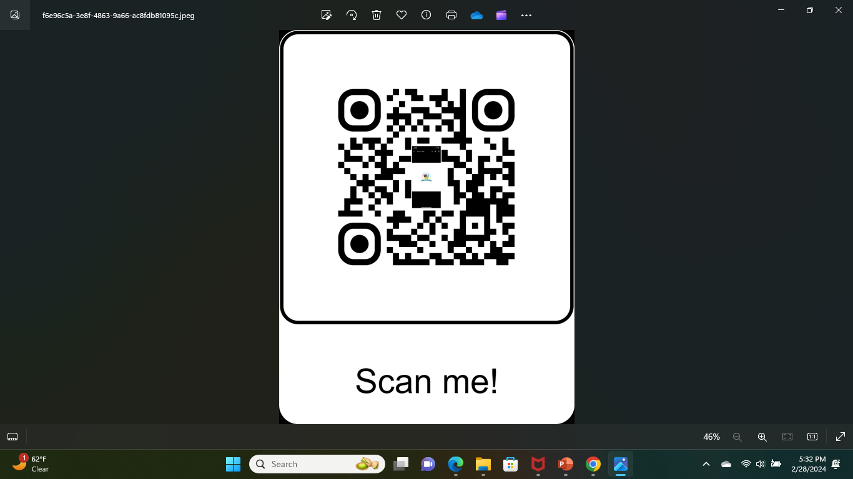  🟦 NAICS Codes:  • 611710 – Educational Support Services  • 541618 – Other Management Consulting  • 541990 – Other Scientific & Technical Services  • 611430 – Professional & Management Development

STEM ADVOCATE LLC provides exposure to STEM, assists in defining a career path in STEM, and enables each student to obtain a ROI in STEM! No students left behind - a scalable STEM career path for everyone!

